Good instinct to want to own the logic completely. Let me walk through every step as if you were explaining it at a whiteboard.

The core problem, stated simply
Your sales data lies to you. If a size sold 15 units and had 15 in stock, you recorded "15 sold" — but the true number of customers who wanted it could have been 18, or 20. You'll never know exactly, but you can make a principled estimate. That's unconstraining: replacing observed (censored) sales with estimated true demand.

Step 1 — Identifying which observations are censored
A row is "censored" when units_sold == units_stocked. This means the shelf ran empty before demand was satisfied. The true demand is somewhere above that number — we just don't know where. Rows where units_sold < units_stocked are "uncensored": the shelf still had stock left at the end, so demand stopped naturally and we observed it fully.
Uncensored: units_sold = 11, units_stocked = 13 → true demand = 11 ✓
Censored: units_sold = 15, units_stocked = 15 → true demand ≥ 15 ?
This is called right-censoring in statistics — you know the true value is at least X, but the exact value is hidden above a threshold.

Step 2 — Building the historical bounds
Before doing any estimation, the code builds a safety profile for every (product, channel, size) combination across all years. This answers the question: what does history tell us is a realistic range for this size in this store?
# For each product-channel-size, look across ALL seasons:
max_stocked = highest stock level ever sent there
max_sold_uncens = highest sales ever recorded when it did NOT stock out
median_str = median sell-through rate in uncensored seasons
n_uncens_seasons = how many seasons we actually observed true demand

These become your guardrails. The imputed demand for any row cannot exceed:
upper_bound = min(
units_stocked × 1.30, # stock ceiling: at most 30% above what was there
max_sold_uncens × growth_cap # history ceiling: at most 25-50% above best observed
)
The growth cap is tighter (1.25×) when you have 2+ uncensored seasons — you know the product well. It's looser (1.50×) when you have little history — you're less certain, so you allow more room. For your S-in-Amsterdam-2018 example: stock was 15, so the stock ceiling is 15 × 1.30 = 19.5. With no prior uncensored history, the history ceiling is 15 × 1.50 = 22.5. The binding constraint is 19.5. The code can never output 115 because it hits this wall first.

Step 3 — The sell-through rate anchor (initialisation)
Before the EM algorithm runs, it needs a starting estimate for censored demand. The code uses a sell-through rate (STR) anchor.
The idea: within a single (product × channel × season) group, the sizes that did not stock out tell you something real about consumer behaviour in that store that season. Their STR — how much of their stock they sold — reflects demand intensity at that moment.
Cell: Amsterdam, product 093, season 2018
L: sold 11 of 12 → STR = 0.917 ← uncensored, observed
M: sold 9 of 9 → STR = 1.0 ← censored
S: sold 15 of 15 → STR = 1.0 ← censored
XL: sold 1 of 1 → STR = 1.0 ← censored

Reference STR = median STR of uncensored sizes = 0.917
For each censored size, the starting estimate is:
initial_demand = units_stocked × reference_STR
= 15 × 0.917 = 13.75 (clipped up to 15, the lower bound)
This is already far more conservative than the old approach. When the whole cell is censored (no uncensored sizes at all), each size falls back to its own historical median STR from previous seasons.

Step 4 — The EM algorithm
EM stands for Expectation-Maximisation. It's an iterative method for estimating parameters when some data is missing or hidden. Here, the "hidden" data is the true demand behind censored sales.
The algorithm assumes demand follows a Normal distribution with mean μ and standard deviation σ. It alternates between two steps until the estimates stop changing.
The E-step (Expectation): Given our current best guess of μ and σ, what is the expected true demand for each censored size?
For a censored row where we know demand ≥ threshold c, the expected value isn't just μ — it's the mean of a Normal distribution truncated from below at c. The formula is:
E[demand | demand ≥ c] = μ + σ × φ((c − μ)/σ) / (1 − Φ((c − μ)/σ))
Where φ is the Normal probability density and Φ is the cumulative distribution. In plain English: "given that demand was at least c, what's the average of all the values it could have been?" This is always greater than μ when c > μ, which is exactly what you'd expect.
The M-step (Maximisation): Take all demand values (observed uncensored ones + E-step estimates for censored ones) and refit μ and σ as simple mean and standard deviation.
Iteration 0: demand estimates = [STR-anchored starting values]
→ compute μ₀, σ₀

Iteration 1: E-step: update censored estimates using μ₀, σ₀
M-step: recompute μ₁, σ₁ from new estimates

Iteration 2: E-step: update censored estimates using μ₁, σ₁
M-step: recompute μ₂, σ₂

... repeat until |μₙ − μₙ₋₁| < 0.00001
After each E-step update, the estimate is immediately clipped to [units_stocked, upper_bound]. This is the key discipline — the EM is free to explore, but the bounds from Step 2 prevent it from ever producing something absurd.

Step 5 — The final output
After convergence, each censored row has a demand_est that satisfies three guarantees:
units_sold ≤ demand_est ≤ upper_bound
The uplift column is simply demand_est − units_sold — the units of hidden demand the algorithm recovered. For uncensored rows, demand_est == units_sold and uplift is zero (you already observed the true demand).
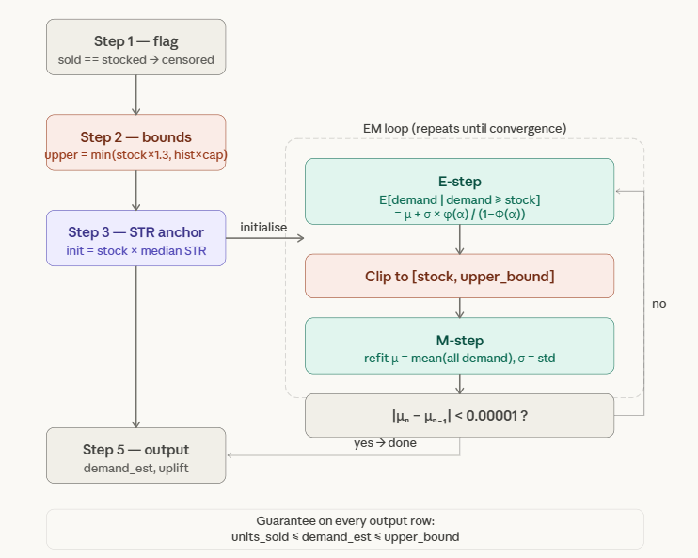
The one-minute version
"We have right-censored sales data — when a size stocks out, we only observe a lower bound on true demand. We use an EM algorithm to estimate the hidden demand. The E-step computes the expected value of a truncated Normal distribution given that demand was at least as large as the stock level. The M-step refits the distribution parameters from all observations, treated and untreated. We initialise using the sell-through rate of non-stocked-out sizes in the same store-season, because that's the cleanest local signal of demand intensity. To prevent the algorithm from extrapolating wildly on sparse data, we pre-compute per-size historical bounds and clip every estimate to those bounds before each M-step. The result is that imputed demand is always consistent with observed history, bounded above by a credible growth factor, and bounded below by the observed sales."
The three things a professor will probe: why EM (because you have latent/hidden variables — classic EM territory), why truncated Normal (because you have a known lower bound, which is exactly what truncated distributions model), and why the STR anchor rather than a prior share (because STR is dimensionless and stable, share-division amplifies noise when shares are small).

